Day 5 : Java

Swing:

* Swing is used to design GUI (Graphical User Interface) applications.
* It is a lightweight component.
* it is a platform independent.
* It follows MVC (Modal View Application).
* It supports pluggable look and feel.
  + javap javax.swing.JFrame
    - setDefaultCloseOperation(int)
    - setDefaultCloseOperation(JFrame.EXIT_ON_CLOSE) // to terminate
  + javap javax.swing.JLabel
  + javap javax.swing.JPanel
  + javap javax.swing.JTextField
  + javap javax.swing.JButton
  + javap javax.swing.JComboBox
  + javap javax.swing.JRadioButton
  + javap javax.swing.JCheckBox
* frame🡨 panel 🡨 components.

public class swingdemo {

    JFrame f;

    JPanel p;

    JLabel l1,l2,l3;

    JButton b1,b2;

    JTextField t1,t2;

swingdemo(){ // done inside the constructor of the class and inside it memory is assignmed to components variable that are created inside the class.

        f = new JFrame();

        p = new JPanel();

        l1= new JLabel("Login");

        l2= new JLabel("Enter Email: ");

        l3= new JLabel("Enter Password:");

        t1 = new JTextField(30);

        t2 = new JTextField(30);

        b1 = new JButton("Sign in");

        b2 = new JButton("Reset");

        f.add(p); // add the panel into the frame

        p.add(l1);

        p.add(l2); // adds the component into the panel

        p.add(t1);

        p.add(l3);

        p.add(t2);

        p.add(b1);

        p.add(b2);

        f.setSize(400,400); // sets the size of the frame width - height

        f.setVisible(true); // makes the window visible by default it is set to false

        f.setDefaultCloseOperation(JFrame.EXIT_ON_CLOSE); // closes the terminal on exit

    }

* awt : abstract window toolkit.
* java.awt.Color has all colors inside and all methods inside it are static
* f.pack(); // packs component into the frame
* p.setBackground(Color.pink); // Don’t forget to import

import java.awt.Color;

p.setBackground(Color.pink);

f.setSize(400,400);

f.pack();



* import java.swing.*; to import all the Classes inside swing Package

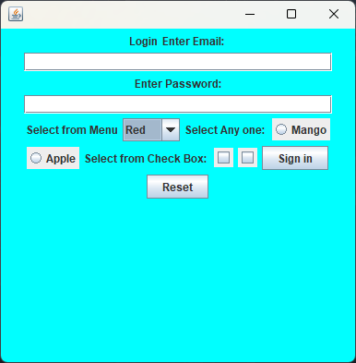

* Button Group : It is used to Select one selection from radio button.
* javap javax.swing.ButtonGroup

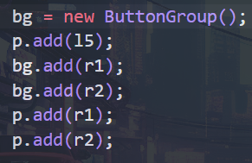

* setBounds(int:x,int:y,int:width,int:height) : it is used to set the Co-ords of Control.
* setFont() : it is used to set the font size and style.
* JPasswordField same as text Field but for password

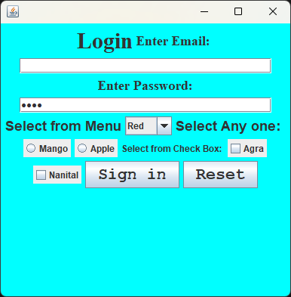

p1 = new JPasswordField(30);

Event Handling in Java

* Event: An Event is Changed the state of an object by performing action.
* An Action can be pressing the button, clicking the mouse etc.

Subpackages

Event Delegation Modal:

Event



Font



Color

* Font and Color are Subpackages of

awt so do event.

* Import java.awt.event.*
* First class will inherit the listener Interface.

|  |  |  |
| --- | --- | --- |
| Class | Interface | Methods |
| ActionEvent | ActionListener | actionPerformed() |
| MouseEvent | MouseListener | * mouseClicked() * mouseReleased() * mousePressed() |
| ItemEvent | ItemListener | itemStateChanged() |
| FocusEvent | FocusListener |  |

* addEventListener() is an intermediate between Source and Listener